FLOOD MONITORING AND EARLY WARNING SYSTEM

FLOOD MONITORING :
As the name indicates, Flood Early Warning System (FLEWS) is a system by which flood induced hazards can be minimized and prevented. Currently different organizations are working on flood forecasting and early warning at national, continental and global scale.

SENSORS IN FMEWS :
Ultrasonic sensors play a vital role in the systems used for these purposes, which makes them important to flood preparedness.

PHASES :
- Selection
- Intervention
- Postintervention monitoring.

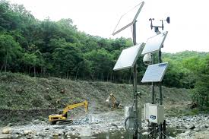
DEVICE USED FOR FLOOD MONITORING :

PROGRAM :
# Import necessary libraries
Import time
Import random

# Define a function to simulate data collection from sensors (e.g., water level sensors)
Def collect_sensor_data():
# Simulate sensor data (replace with actual sensor readings)
Return random.uniform(0.0, 10.0)

# Define a function to analyze sensor data and make decisions
Def analyze_data(data):
# Set a threshold for flooding detection
Threshold = 7.0
If data > threshold:
Return True # Flooding detected
Else:
Return False # No flooding

# Define a function to send alerts
Def send_alert():
# Implement alerting mechanism (e.g., send emails, text messages, or use an API)
Print(“Flood Alert: Flooding detected! Take necessary actions.”)

# Main loop for continuous monitoring
While True:
# Collect sensor data
Sensor_data = collect_sensor_data()

# Analyze the data
If analyze_data(sensor_data):
# Send an alert if flooding is detected
Send_alert()

# Sleep for a specific interval before the next data collection
Time.sleep(60) # Adjust the time interval as needed

